43.17: If 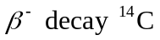is possible, then we are considering the decay 